Test Case: tc005_SPX_Dev5_Crear_Requisicion_Spot_Con_FAD_Tipo_Cobro_Project
Step 1 - Enter username and password and click to button Enter: Credentials Entered
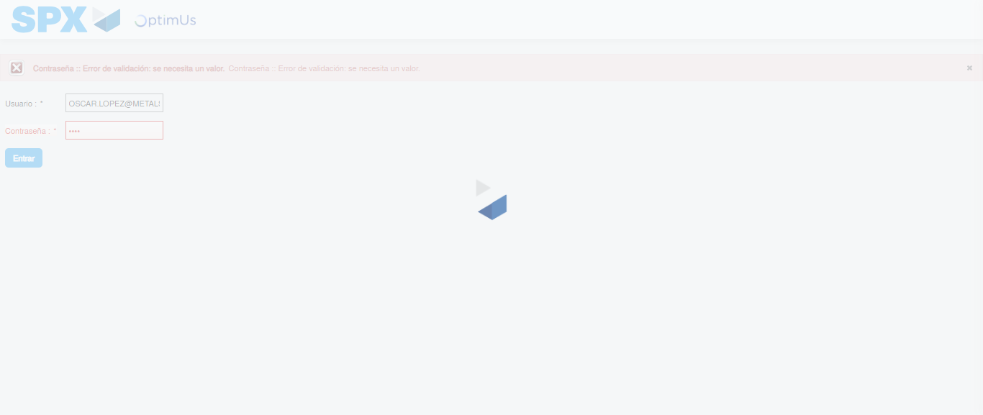Image file-name: QC_Testing-tc005_SPX_Dev5_Crear_Requisicion_Spot_Con_FAD_Tipo_Cobro_Project-1784570662515

Step 2 - Select to UEN and Access to Spot Buy Requisitions : UEN Correctly selected and Correct access
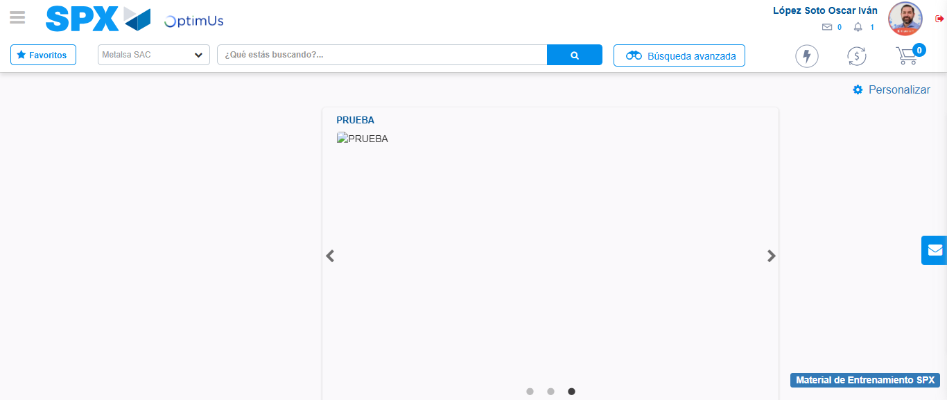Image file-name: QC_Testing-tc005_SPX_Dev5_Crear_Requisicion_Spot_Con_FAD_Tipo_Cobro_Project-1784570733246

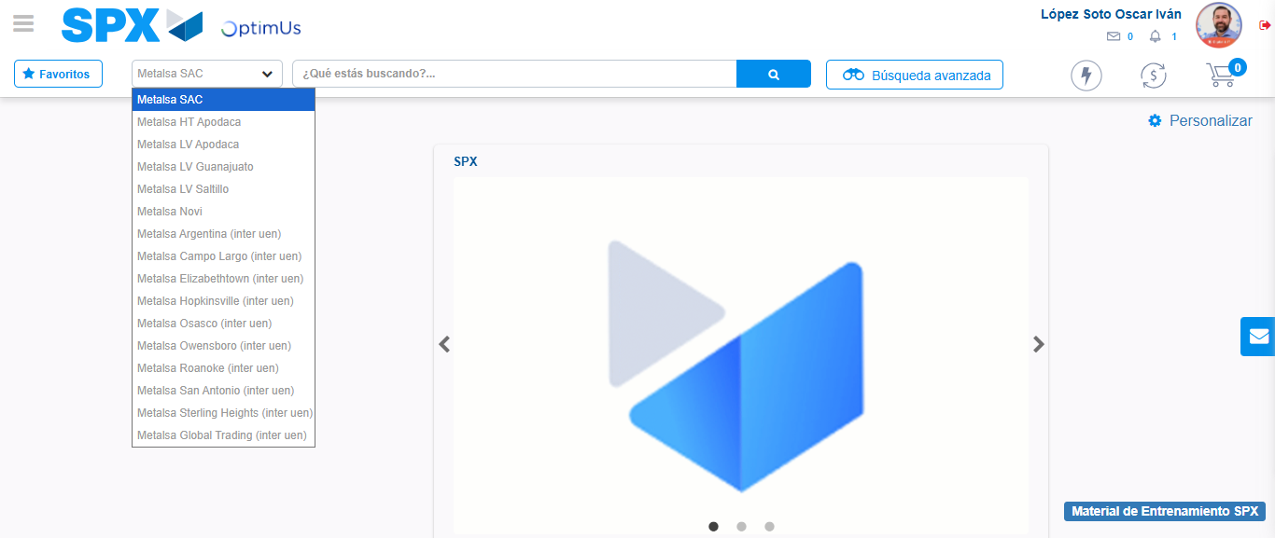Image file-name: QC_Testing-tc005_SPX_Dev5_Crear_Requisicion_Spot_Con_FAD_Tipo_Cobro_Project-1784570736053

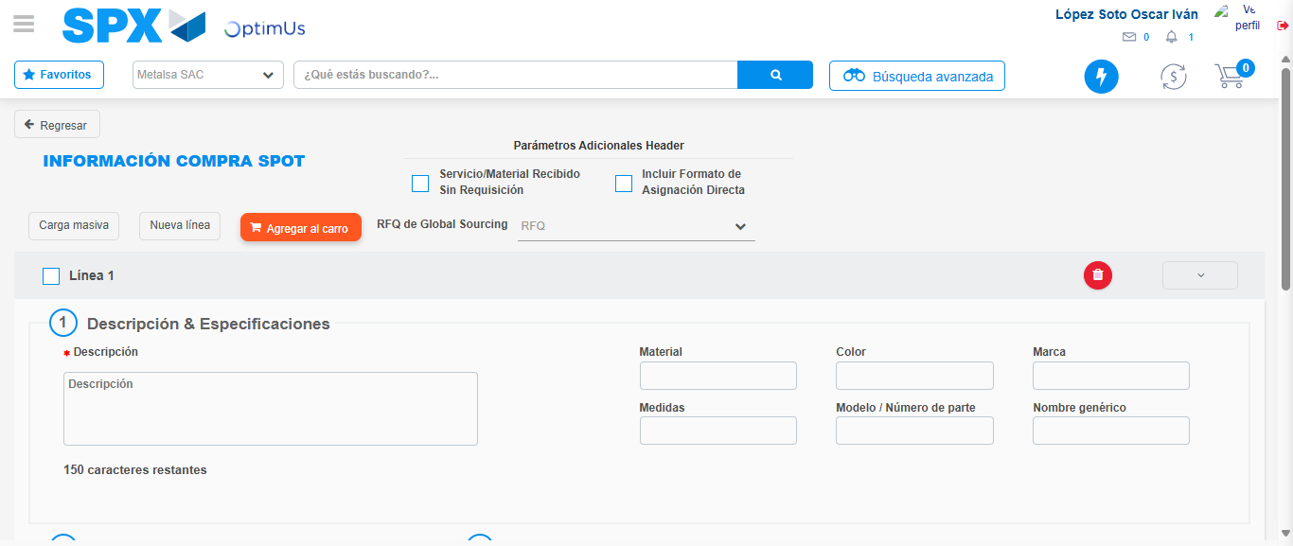Image file-name: QC_Testing-tc005_SPX_Dev5_Crear_Requisicion_Spot_Con_FAD_Tipo_Cobro_Project-1784570748023

Step 3 - Add FAD to Requisition: FAD Successfully Added
Image file-name: QC_Testing-tc005_SPX_Dev5_Crear_Requisicion_Spot_Con_FAD_Tipo_Cobro_Project-1784570748291

Image file-name: QC_Testing-tc005_SPX_Dev5_Crear_Requisicion_Spot_Con_FAD_Tipo_Cobro_Project-1784570748484

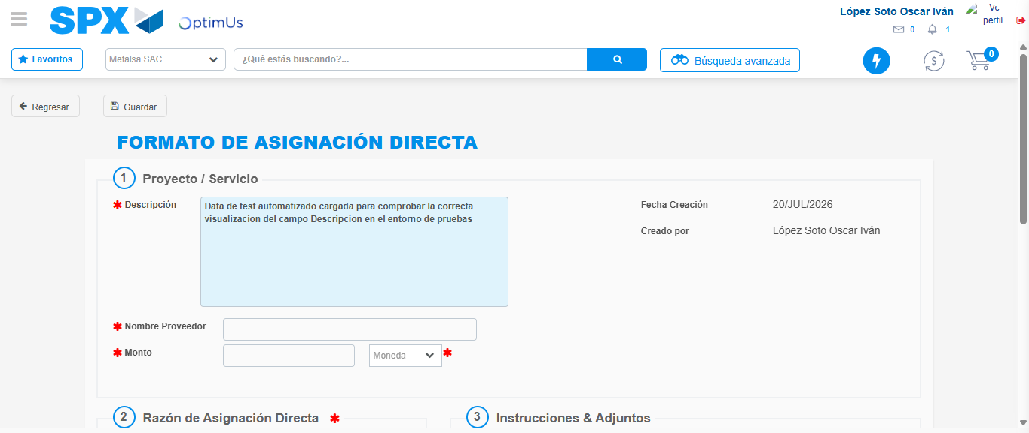Image file-name: QC_Testing-tc005_SPX_Dev5_Crear_Requisicion_Spot_Con_FAD_Tipo_Cobro_Project-1784570751478

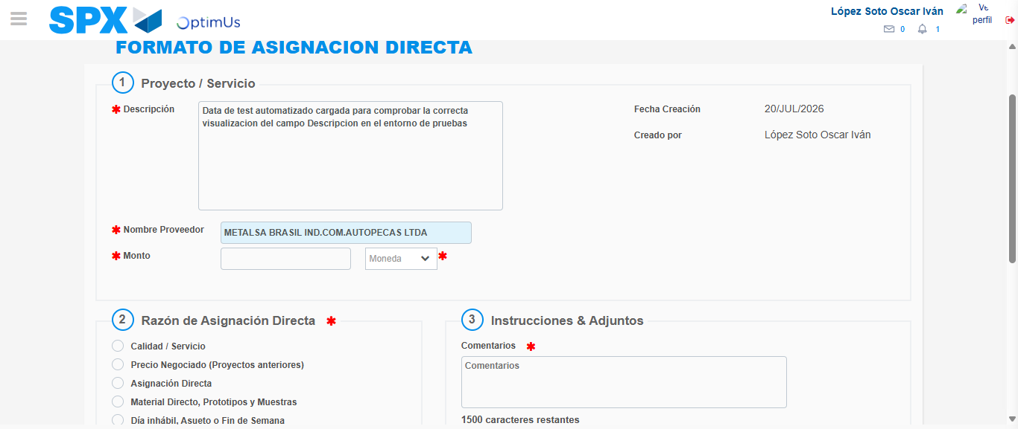Image file-name: QC_Testing-tc005_SPX_Dev5_Crear_Requisicion_Spot_Con_FAD_Tipo_Cobro_Project-1784570757808

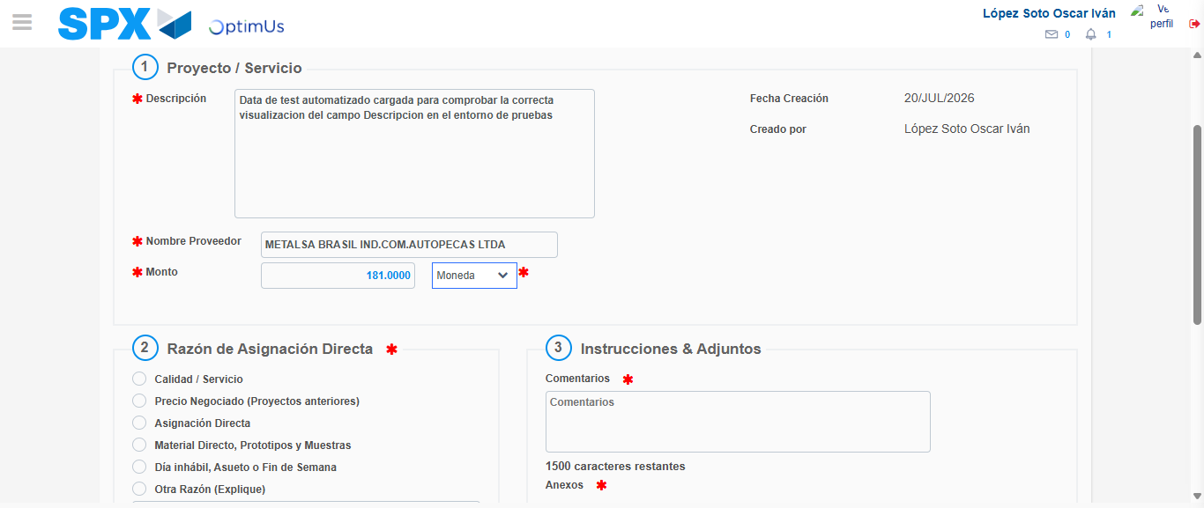Image file-name: QC_Testing-tc005_SPX_Dev5_Crear_Requisicion_Spot_Con_FAD_Tipo_Cobro_Project-1784570758371

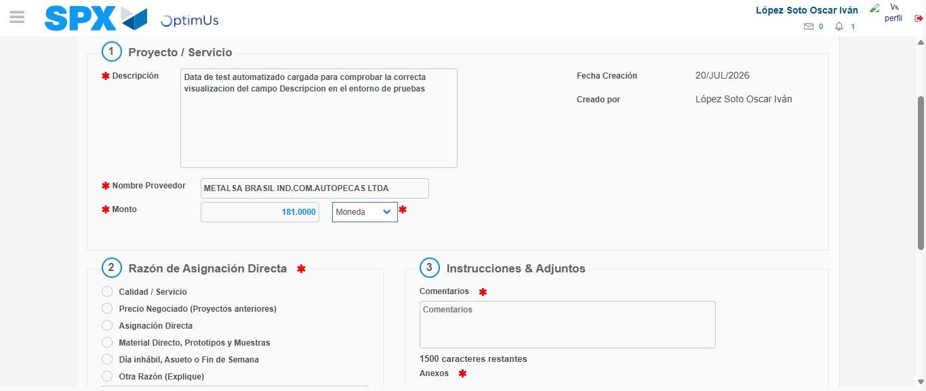Image file-name: QC_Testing-tc005_SPX_Dev5_Crear_Requisicion_Spot_Con_FAD_Tipo_Cobro_Project-1784570758631

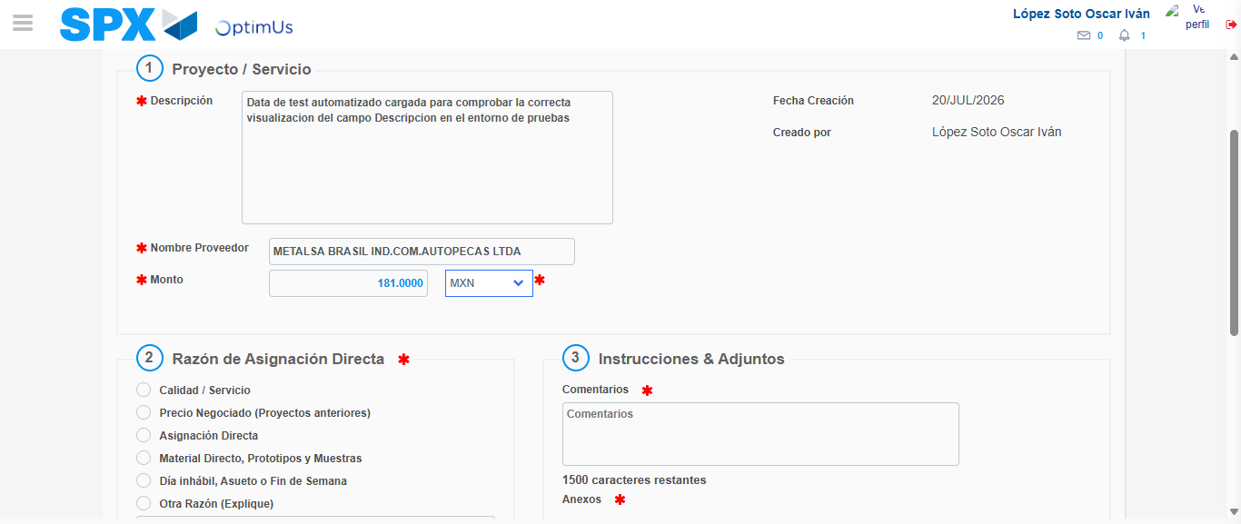Image file-name: QC_Testing-tc005_SPX_Dev5_Crear_Requisicion_Spot_Con_FAD_Tipo_Cobro_Project-1784570759140

Image file-name: QC_Testing-tc005_SPX_Dev5_Crear_Requisicion_Spot_Con_FAD_Tipo_Cobro_Project-1784570759385

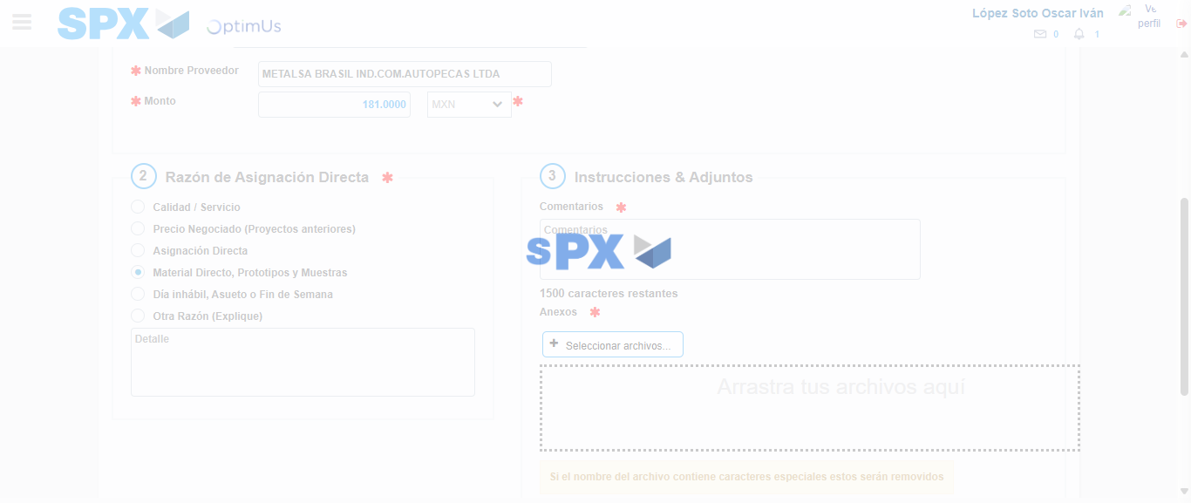Image file-name: QC_Testing-tc005_SPX_Dev5_Crear_Requisicion_Spot_Con_FAD_Tipo_Cobro_Project-1784570760377

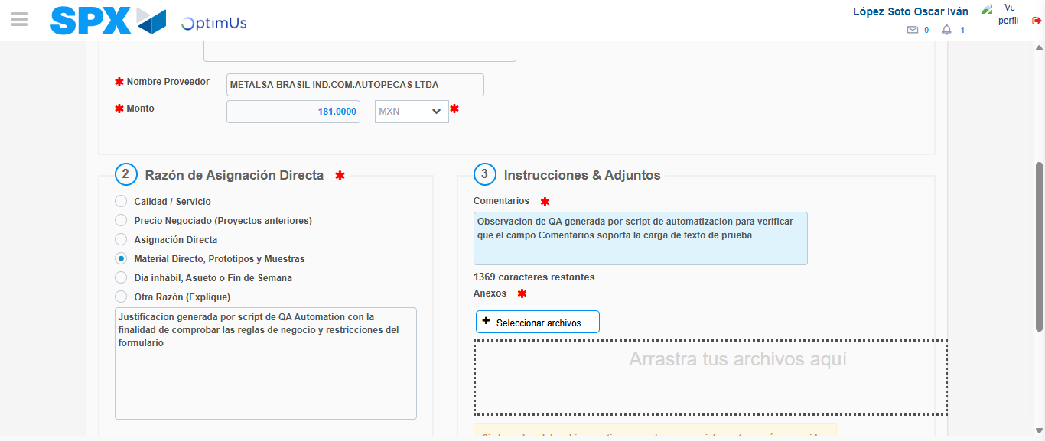Image file-name: QC_Testing-tc005_SPX_Dev5_Crear_Requisicion_Spot_Con_FAD_Tipo_Cobro_Project-1784570771796

Image file-name: QC_Testing-tc005_SPX_Dev5_Crear_Requisicion_Spot_Con_FAD_Tipo_Cobro_Project-1784570772517

Step 4 - Data Capture Spot Buy Requisition: Data captured correctly
Image file-name: QC_Testing-tc005_SPX_Dev5_Crear_Requisicion_Spot_Con_FAD_Tipo_Cobro_Project-1784570748291

Image file-name: QC_Testing-tc005_SPX_Dev5_Crear_Requisicion_Spot_Con_FAD_Tipo_Cobro_Project-1784570748484

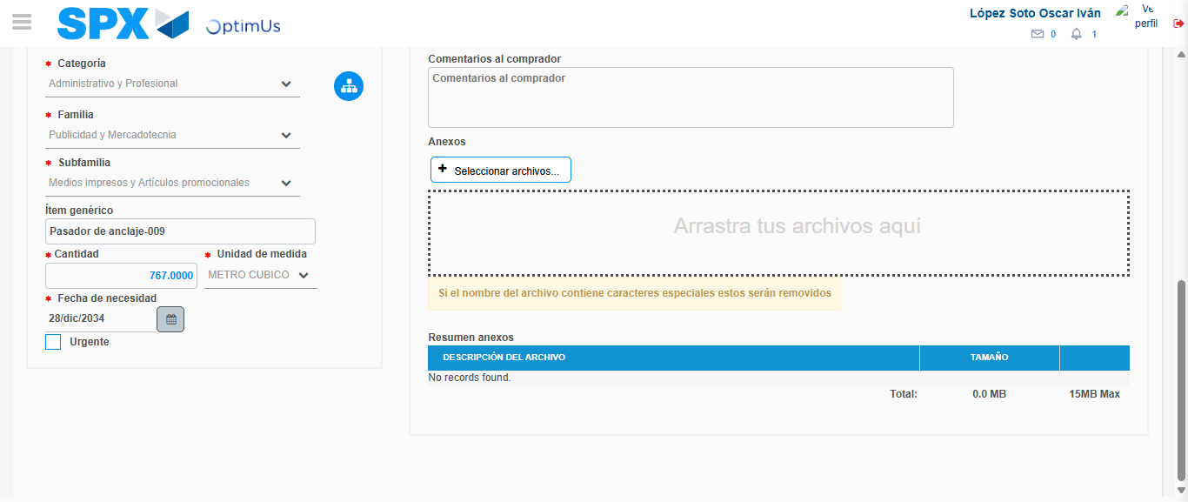Image file-name: QC_Testing-tc005_SPX_Dev5_Crear_Requisicion_Spot_Con_FAD_Tipo_Cobro_Project-1784570786047

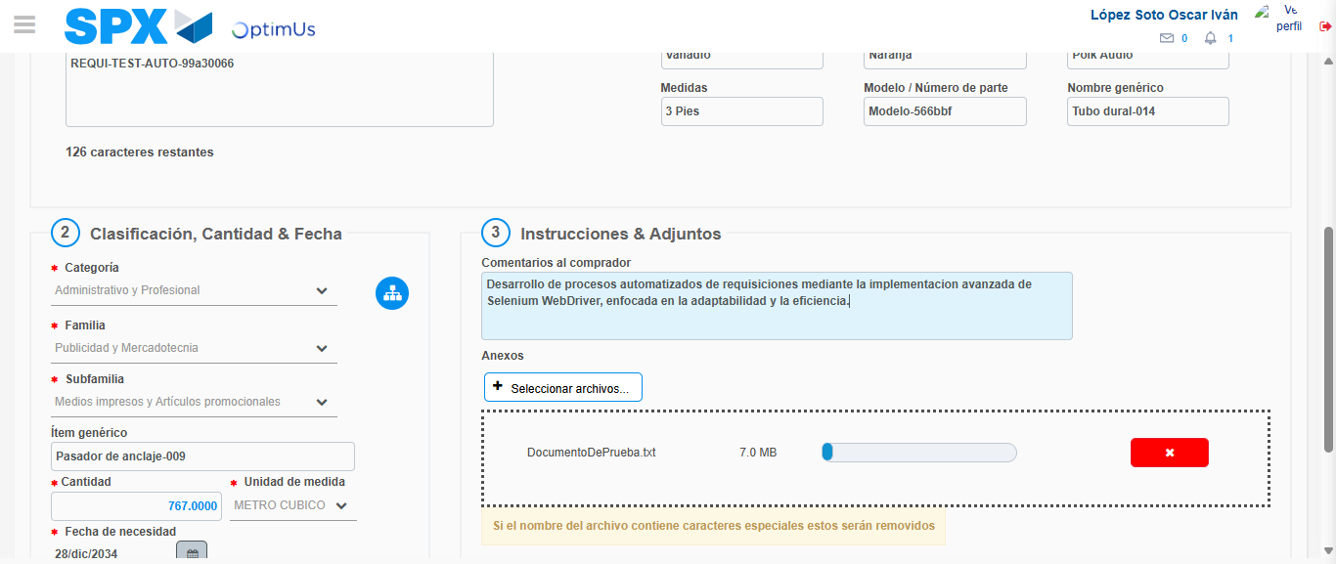Image file-name: QC_Testing-tc005_SPX_Dev5_Crear_Requisicion_Spot_Con_FAD_Tipo_Cobro_Project-1784570786979

Step 8 - Return to Main Page SPX : Return to Main Page SPX
Image file-name: QC_Testing-tc005_SPX_Dev5_Crear_Requisicion_Spot_Con_FAD_Tipo_Cobro_Project-1784570733246

Image file-name: QC_Testing-tc005_SPX_Dev5_Crear_Requisicion_Spot_Con_FAD_Tipo_Cobro_Project-1784570736053

Image file-name: QC_Testing-tc005_SPX_Dev5_Crear_Requisicion_Spot_Con_FAD_Tipo_Cobro_Project-1784570748023

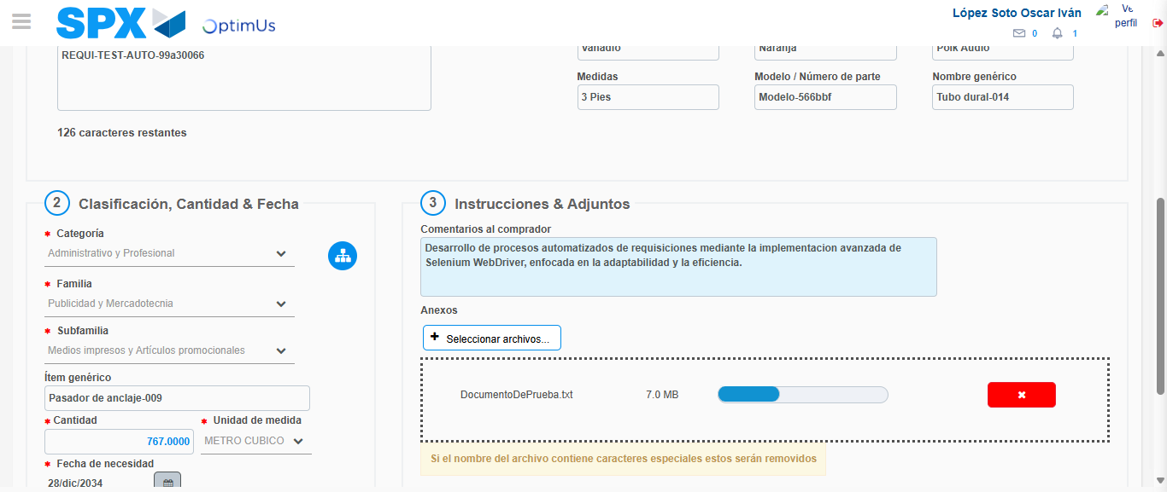Image file-name: QC_Testing-tc005_SPX_Dev5_Crear_Requisicion_Spot_Con_FAD_Tipo_Cobro_Project-1784570789291

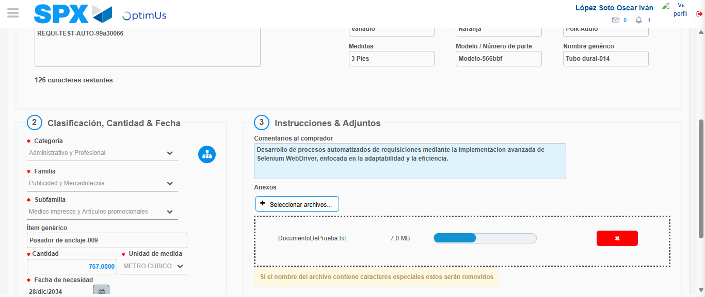Image file-name: QC_Testing-tc005_SPX_Dev5_Crear_Requisicion_Spot_Con_FAD_Tipo_Cobro_Project-1784570789474

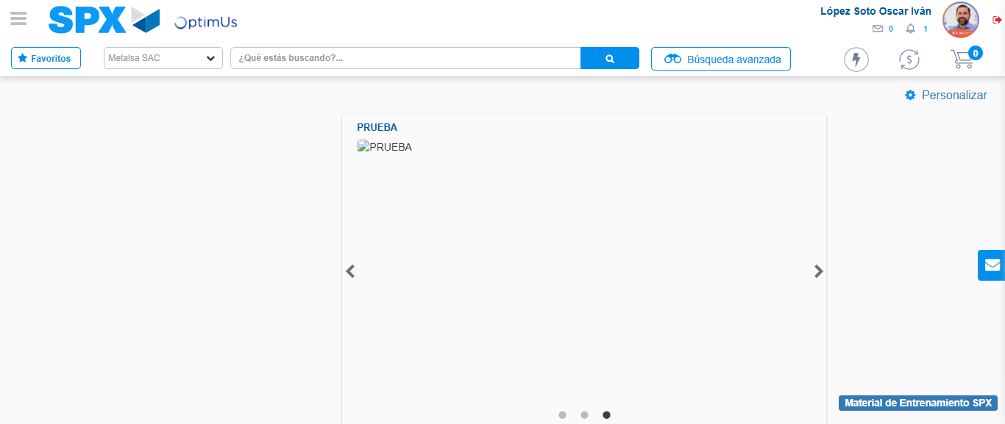Image file-name: QC_Testing-tc005_SPX_Dev5_Crear_Requisicion_Spot_Con_FAD_Tipo_Cobro_Project-1784570810911

Step 9 - Log Out : Log Out SPX
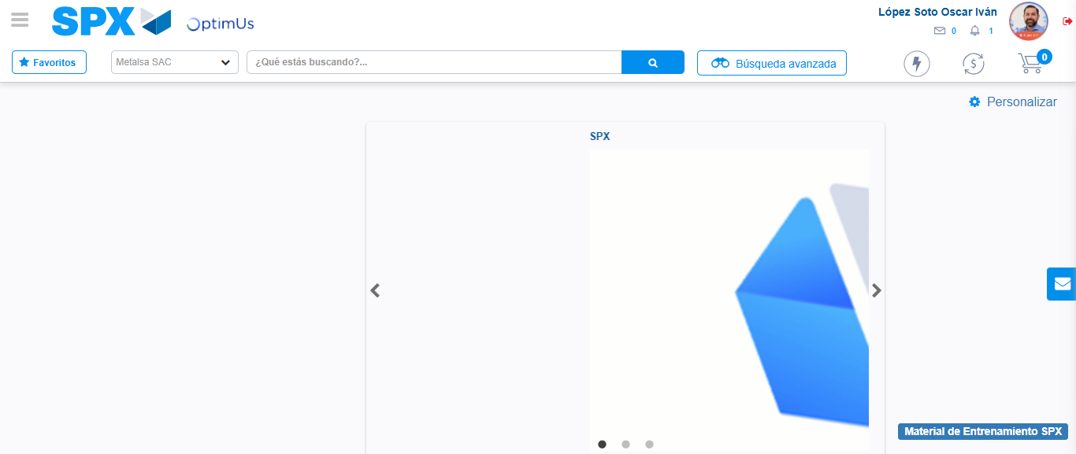Image file-name: QC_Testing-tc005_SPX_Dev5_Crear_Requisicion_Spot_Con_FAD_Tipo_Cobro_Project-1784570811243

